Hello, 4th Grade Parents!

**[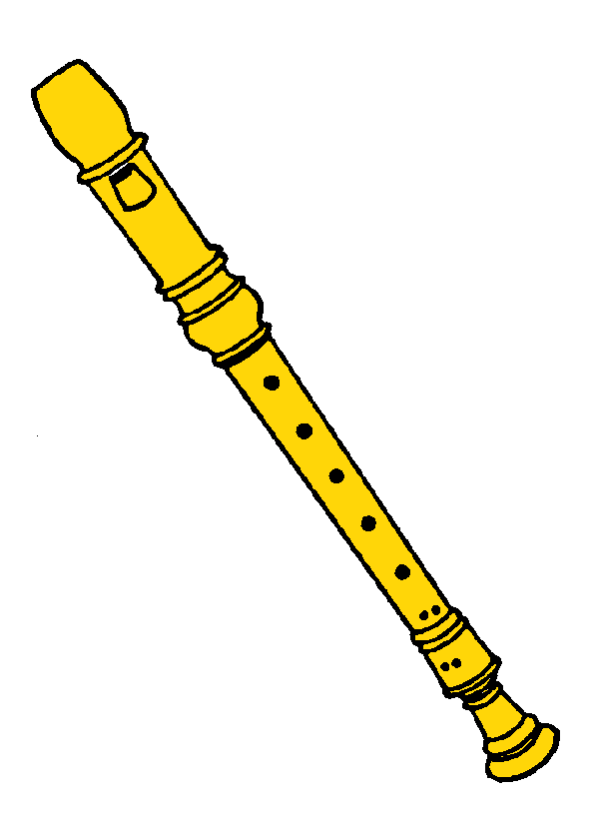](http://www.srwschool.cc/wp-content/uploads/2012/01/recorder.gif)**Part of your 4th grader’s musical experience is learning how to play the recorder.

The recorder is a flute-like woodwind instrument that is fun to play. Every student will benefit from having his/her own personal recorder. We have already placed an order for students who need to purchase one. Many of the students may have older brothers or sisters who purchased a recorder when they were in 4th grade and are planning on using their sibling’s recorder. That is great! Please make sure that all of the parts are there and you have located it. If you are unable to purchase a recorder please let me know and we will have one available for your child to use.

Fill out the form below and return it to your child’s classroom teacher**. Everyone needs to complete the form even if you don’t plan on purchasing a recorder.**  Please check the appropriate statement and return as soon as possible.

Sincerely,

Sarah Coleman, scoleman@washoeschools.net

General Music Teacher

Brown Elementary

*****************************************************************************************

Student’s Name_______________________________Classroom Teacher_________________

_____I have a recorder and **DO NOT** need to purchase one.

_____I need to **borrow** a recorder from the music room.

**_____** I would like to **order** a recorder and have enclosed $6 to pay for the recorder, shipping, and recorder PPE.

**(If writing a check – make payable to BROWN ELEMENTARY.)**